# **CSC 431** <Project Name> System Architecture Specification (SAS)

**<Team number>**

|  |  |
| --- | --- |
| <Member Name> | <Role> |
| <Member Name> | <Role> |
| <Member Name> | <Role> |
| <Member Name> | <Role> |

# Version History

|  |  |  |  |
| --- | --- | --- | --- |
| Version | Date | Author(s) | Change Comments |
|  |  |  |  |
|  |  |  |  |
|  |  |  |  |
|  |  |  |  |

# Table of Contents

1. System Analysis 6

1.1 System Overview 6

1.2 System Diagram 6

1.3 Actor Identification 6

1.4 Design Rationale 6

1.4.1 Architectural Style 6

1.4.2 Design Pattern(s) 6

1.4.3 Framework 6

2. Functional Design 7

2.1 Diagram Title 7

3. Structural Design 8

4. Behavioral Design 9

# Table of Tables

<Generate table here>

# Table of Figures

<Generate table here>

### System Analysis

#### System Overview

<Describe the system in brief and your architecture choice>

#### System Diagram

<Insert System Diagram>

#### Actor Identification

<Identify all actors interacting with the system>

#### Design Rationale

##### Architectural Style

<Identify and briefly explain the architectural style e.g. 3-tier architecture>

##### Design Pattern(s)

<Identify the design pattern(s) you have deemed applicable to this architecture>

##### Framework

<Identify and briefly explain the frameworks you are using, if any. Also specify the rationale behind selecting this framework>

### Functional Design

<Identify all significant workflows as sequence diagrams using the following format>

#### Diagram Title

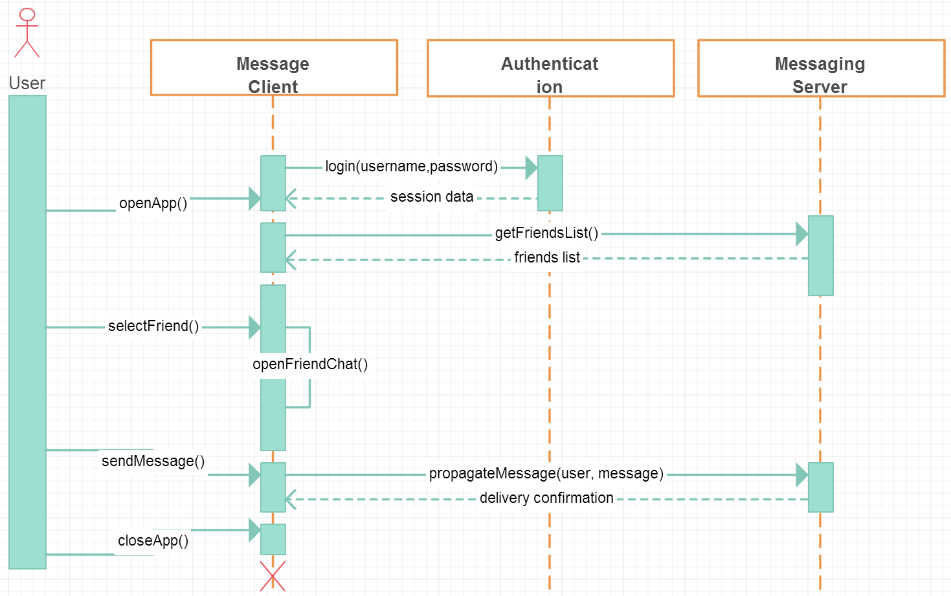

### Structural Design

<Identify all components and model them using class diagrams>